Introduction
This document provides step-by-step instructions for proper installation of the Paradigm Generic USB device driver on Windows XP or Vista. Depending on your operating system settings you may not see the exact dialogs and messages that are referenced in this document however the general procedure should be the same.
Please note that the procedure differs for Windows Vista from Windows XP. Be sure to follow the correct instructions.

Before starting
You will need to be logged in as an administrative user to install the software and device drivers.
If your operating system is windows XP you will need to make sure that your computer is not set to block unsigned windows device drivers. If you are unsure of how to do this go to ‘Allowing unsigned device driver installation’.
Before connecting your Paradigm Subwoofer with USB make sure to install at least one of the utilities that use USB to communicate with a Paradigm USB device. For a list of available software that uses USB to communicate with the Paradigm USB device go to Products and Utilities that install drivers as part of their installation. The following steps will fail if you have not properly installed at least one of the utilities that use USB to communicate with a Paradigm USB device.

Table of Contents

Introduction 1
Before starting 1
Table of Contents 2
Installation Instructions for windows XP 3
Step 1 3
Step 2 3
Step 3 3
Step 4 4
Installation Instructions for Windows Vista 5
Products and Utilities that install drivers as part of their installation 5
Troubleshooting 6
Allowing unsigned device driver installation 6
Windows XP 6
Windows Vista 7
How do I force the device driver to be installed on Windows XP? 7
Step 1 7
Step 2 7
Step 3 8
How do I force the device driver to be installed on Windows Vista? 8
Step 1 8
Step 2 9
Step 3 9
Step 4 10
Step 5 10

Installation Instructions for windows XP

Step 1
Before connecting your Paradigm Subwoofer with USB make sure to install at least one of the utilities that use USB to communicate with a Paradigm USB device. For a list of available software that uses USB to communicate with the Paradigm USB device go to Products and Utilities that install drivers as part of their installation. The following steps will fail if you have not properly installed at least one of the utilities that use USB to communicate with a Paradigm USB device. Once you have done this, proceed to step 2.

For windows XP the USB device driver is installed on a per-port basis. This means that you will need to repeat steps 2-4 each time you connect a Paradigm USB device to a new USB port.

Step 2
Connect your Paradigm USB device via USB. If the following dialog pops up then make the selection as shown in the image, click on ‘Next’ and then proceed to step 3. If the dialog in step 3 is shown, then proceed to step 3. If no dialog is shown, refer to section titled Troubleshooting: How do I force the device driver to be installed?.
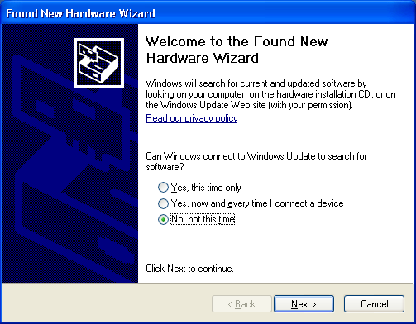

Step 3
One of the following dialogs will appear. In either case, select ‘Install the software automatically (Recommended)’ and click next. Proceed to step 4.
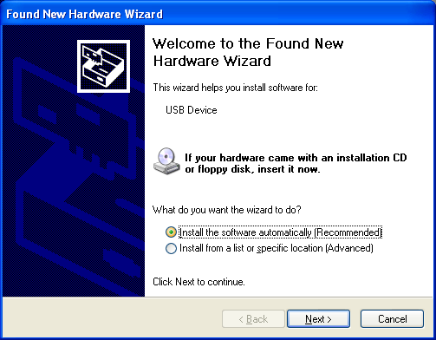
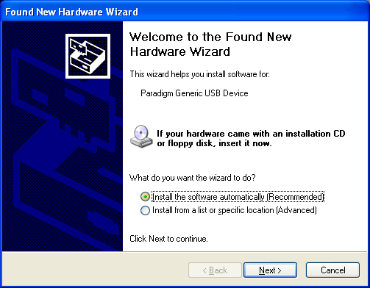

Step 4
At some point the following dialog may be displayed.
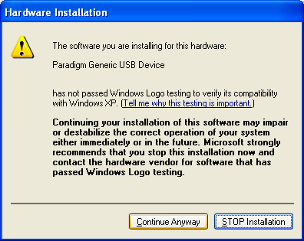
You will need to select ‘Continue anyway’ in order to properly install the Paradigm Generic USB device.

Once the installation completes successfully you should see the following dialog.
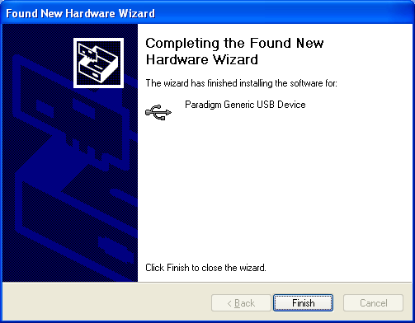

Installation Instructions for Windows Vista

Before connecting your Paradigm Subwoofer with USB make sure to install at least one of the utilities that use USB to communicate with a Paradigm USB device. For a list of available software that uses USB to communicate with the Paradigm USB device go to Products and Utilities that install drivers as part of their installation. The following steps will fail if you have not properly installed at least one of the utilities that use USB to communicate with a Paradigm USB device.

On windows Vista the device driver is completely installed during the software installation of the various utilities mentioned above. During the device driver installation you may be prompted with the following dialog. You will need to select ‘Install this driver software anyway’ in order to properly install the Paradigm Generic USB device.
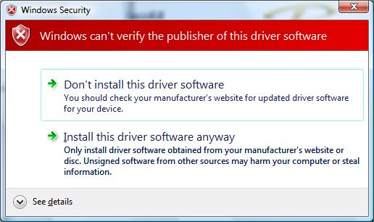

There is no need for any additional user guided software installation. If you are still having problems connecting to a Paradigm USB device or the dialog bellow appears when you connect a Paradigm USB device refer to the section titled Troubleshooting: How do I force the device driver to be installed?.

If you get the dialog shown bellow when you connect the USB device, click on cancel and then go to Troubleshooting: How do I force the device driver to be installed?. (The device driver installation most likely failed during the installation of one of the utilities)
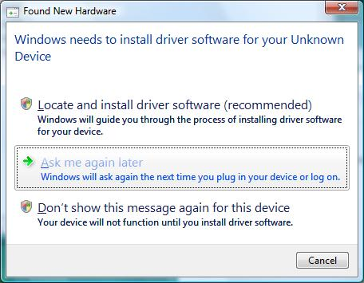

Products and Utilities that install drivers as part of their installation
As of the writing of this document, the following Paradigm utilities provide a windows installer that also installs the Paradigm Generic USB device driver:
- Paradigm PBK-1
- Studio Sub 12 Installer (firmware updates for the Studio Sub 12)
- Studio Sub 15 Installer (firmware updates for the Studio Sub 15)
- X850 Configurator (firmware updates and configuration for the X850 subwoofer amplifier)
- Signature Sub 25 Installer (firmware updates for the Signature Sub 25)

Troubleshooting
This section includes some troubleshooting instructions.

Allowing unsigned device driver installation
This section describes the steps required to modify your PC to allow the installation of unsigned device drivers. This is required to install the Paradigm Generic USB device driver.

Windows XP
Click on ‘Start’ then right click on ‘My Computer’ and go to properties. You will see the following dialog:
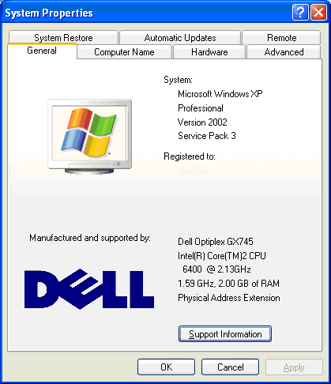

Click on the ‘Hardware’ tab:
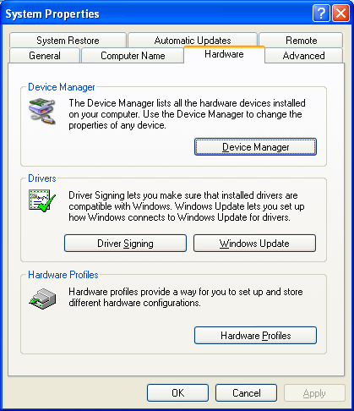
Click on ‘Driver Signing’:
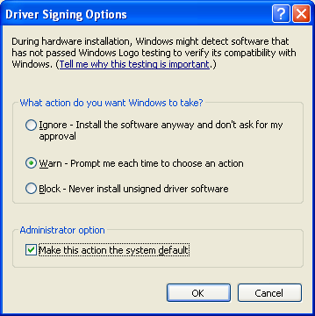
Make sure that ‘Block’ is not the selected option. After you have completed the installation you should return to this menu and change the settings back to their original value.

Windows Vista
There is no option to control this on windows Vista. The action taken will always be to warn the user.

How do I force the device driver to be installed on Windows XP?
Before connecting your Paradigm Subwoofer with USB make sure to install at least one of the utilities that use USB to communicate with a Paradigm USB device. For a list of available software that uses USB to communicate with the Paradigm USB device go to Products and Utilities that install drivers as part of their installation. The following steps will fail if you have not properly installed at least one of the utilities that use USB to communicate with a Paradigm USB device.

Step 1
Click on ‘Start’ then right click on ‘My Computer’ and go to properties. You will see the following dialog. Click on the ‘Hardware’ tab.

Step 2
Click on ‘Device Manager’

Step 3
Right click on ‘USB Device’ and select ‘Update driver...’
You can now proceed to step 3 of installing the device driver on windows XP.
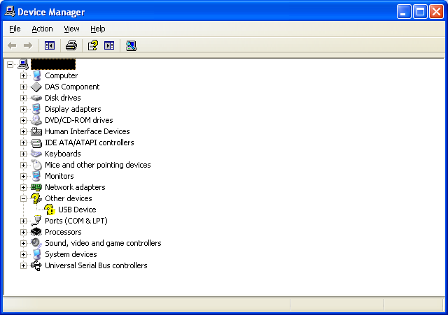

How do I force the device driver to be installed on Windows Vista?
Before connecting your Paradigm Subwoofer with USB make sure to install at least one of the utilities that use USB to communicate with a Paradigm USB device. For a list of available software that uses USB to communicate with the Paradigm USB device go to Products and Utilities that install drivers as part of their installation. The following steps will fail if you have not properly installed at least one of the utilities that use USB to communicate with a Paradigm USB device.

Step 1
Go to the start menu. Left click on ‘Control Panel’. You should now see something that looks like the following dialog. Click on ‘Device Manager’.
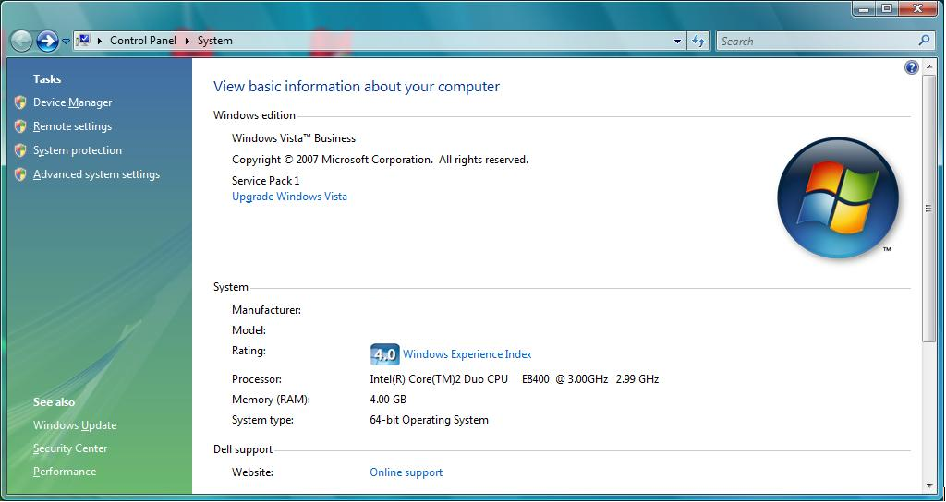

Step 2
Expand the item ‘Other devices’. Right click on ‘Unknown device’ and select ‘Update driver software’.
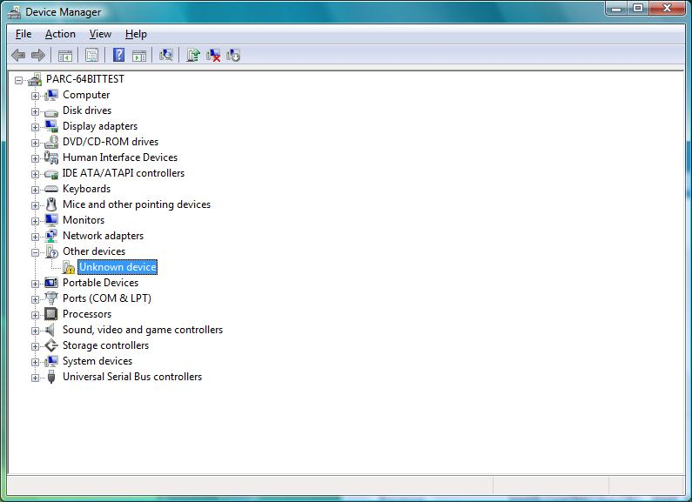

Step 3
Click on ‘Don’t search online’
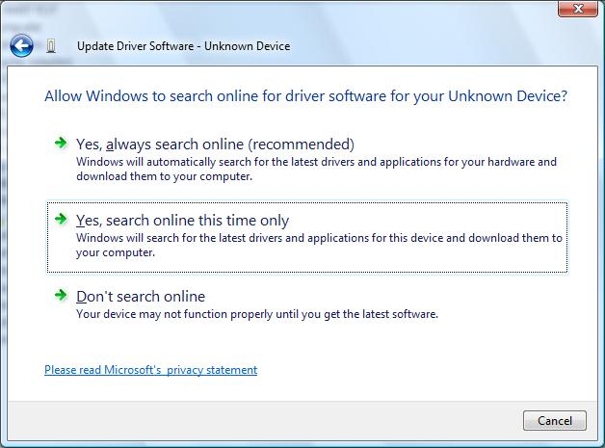

Step 4
Click on ‘Search automatically for updated driver software’
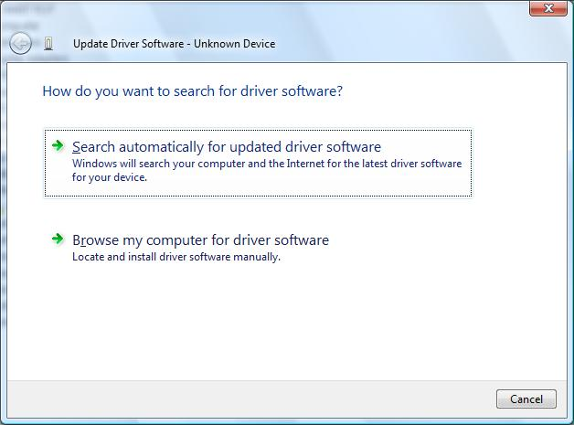

Step 5
At some point the following dialog may be displayed.
You will need to select ‘Install this driver software anyway’ in order to properly install the Paradigm Generic USB device.

